Amatak Yvi
CSC 201 040L
Professor. Qamar Munawer
Date: 03/21/2022

HOMEWORK 1

1. (a) Create a class PayCalculator that has an attribute payRate given in
dollars per hour. The class should also have a method computePay(hours)
that returns the pay for a given amount of time.

import java.math.BigDecimal;
public abstract class PayCalculator {
BigDecimal payRate;
public PayCalculator(BigDecimal payRate){
this.payRate = payRate;
}
public abstract BigDecimal computePay(float hour);

Import java.math.BigDecimal;
Public class RegularPay extends PayCalculator {
Public RegularPay(BigDecimal payRate){
Super(payRate);
}
Public BigDecimal computerPay(float hour){
Return (payRate.multiply(new BigDecimal(hour));
}
}
Import java.math.BigDecimal;
Public class HazardPay extends PayCalculator {
Public HazardPay(BigDecimal payRate){
Super(payRate);
}
Public BigDecimal computerPay(float hour){
Return payRate.multiply(new BigDecimal(hour)).multiply(new BigDecimal(1.5));
}
}

(b) Derive a class RegularPay from PayCalculator, as described in 1(a) above exercise.
It should have a constructor that has a parameter for the pay rate. It should not override any of the methods. Then derive a class HazardPay from PayCalculator that overrides the computePay method. The new method should return the amount returned by the base class method multiplied by 1.5.
( Copy the code here)
import java.math.BigDecimal;
public class HomeworkOne {
public static void main(String [] args) {
BigDecimal payRate = new BigDecimal(35);
RegularPay rp = new RegularPay(payRate);
System.out.println(rp.computePay(10));

PayCalculator pay = new HazardPay(payRate);
System.out.println(pay.computePay(10));
}

}
Copy results screen shot here: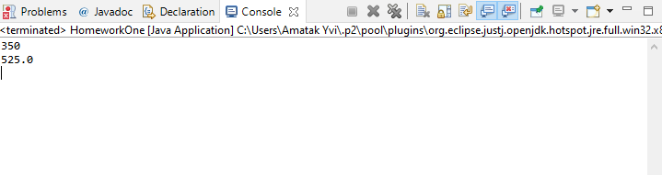
2. Write a program that lets the user guess whether the flip of
a coin results in heads or tails. The program randomly generates an integer 0 or 1,
which represents head or tail. The program prompts the user to enter a guess and
reports whether the guess is correct or incorrect.
Use following to rendomly generate 0 or 1
// Obtain the random number 0 or 1
int number = (int)(Math.random() * 2);
(Copy the program and its output here)
import java.util.Scanner;
import java.util.Random;
public class Homework1TailHead {
public static void main(String[] args){
@SuppressWarnings("resource")
Scanner in = new Scanner(System.in);
Random random = new Random();
int coin_flip = random.nextInt(2);
System.out.print("Enter 1 for heads, 0 for tails CoinFlip ");
int guess = in.nextInt();
if(guess == coin_flip){
System.out.println("You guess right, congrats!");
}else{
System.out.println("Sorry, you guessed wrong, try again.");
}

}

}
( Copy the result screen shot😊
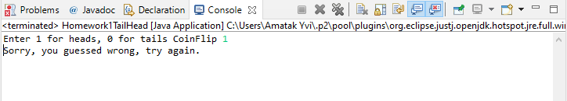
3.Which of the following assignment statements is correct to assign character 5 to c?

a. char c = 5;
b. char c = “5";
c. char c = '5';
d. char c = "344";
- b. char c = “5";
4. What is the output of the following code: (Please indent the statement correctly first.)
int x = 9;
int y = 8;
int z = 7;
if (x > 9)
if (y > 8)
System.out.println("x > 9 and y > 8");
else if (z >= 7)
System.out.println("x <= 9 and z >= 7");
else
System.out.println("x <= 9 and z < 7");
a. x > 9 and y > 8;
b. x <= 9 and z >= 7;
c. none
d. x <= 9 and z < 7;

- c. none

